## Drawing in Bridge Rails

1. Using the **Polyline** tool from the Lines tab, draw in the bridge rails.

* 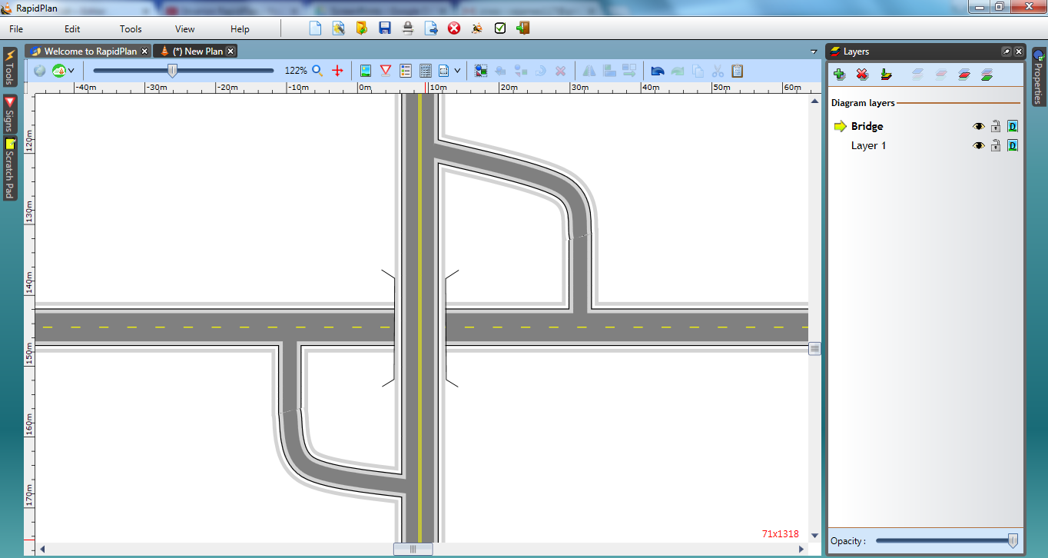
* Overpasses_and_Underpasses_steps_7_and_8